LOCATION PROGRAM

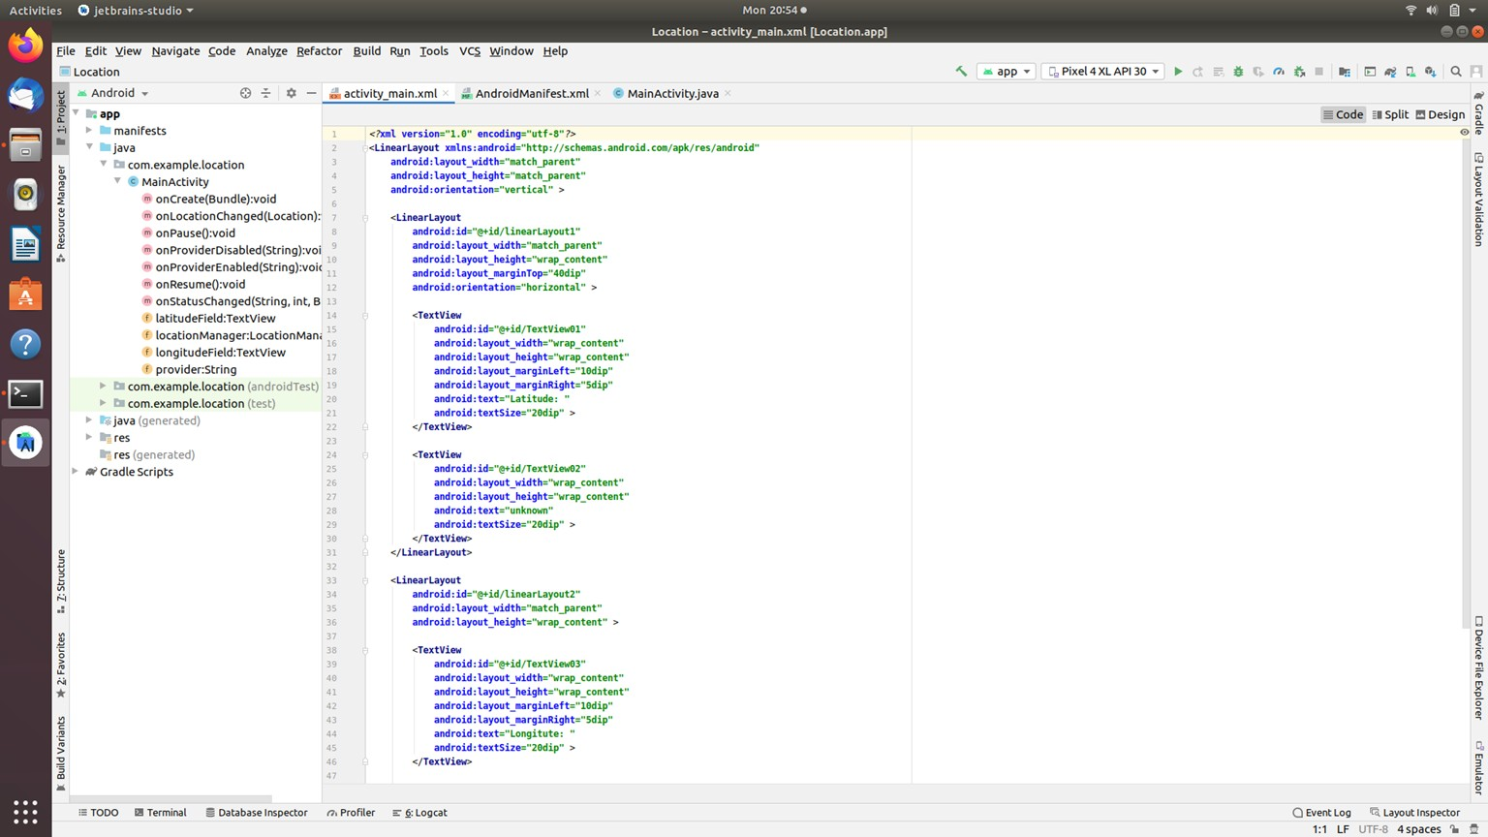

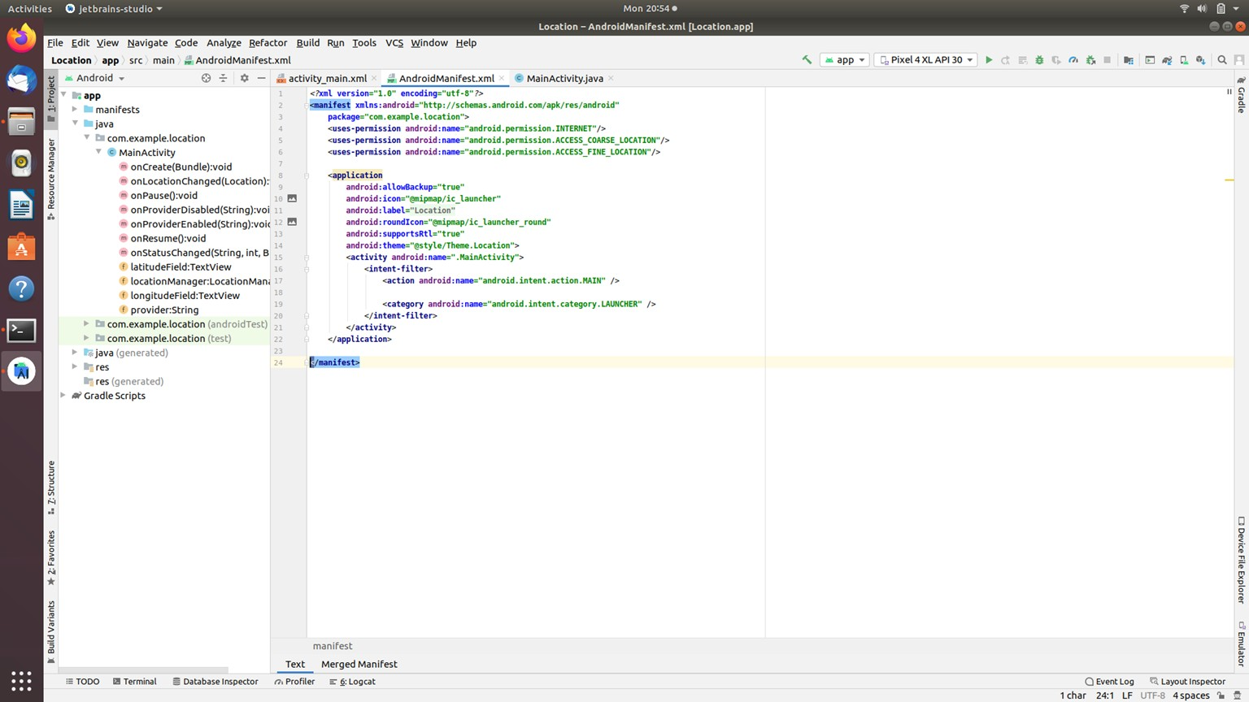

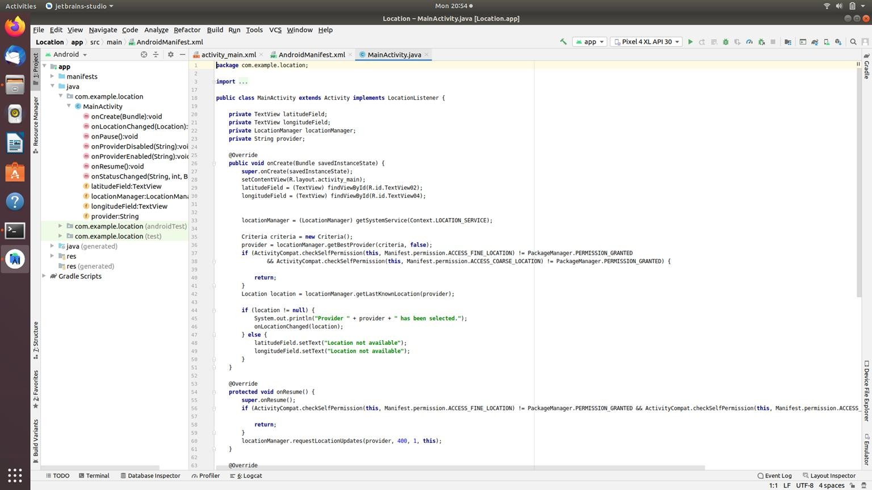

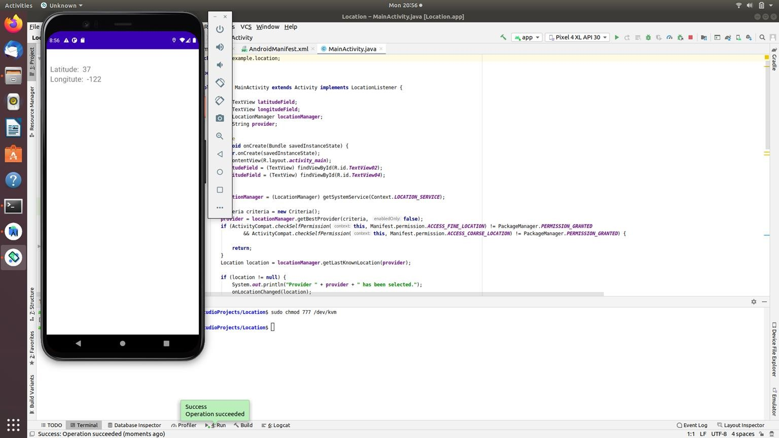



## •$- RV college of engineering X g



9 p

 

Rv coli+rte of

Eng inneting'fi.'





RVCE Founders’ 









B. Glo

## VCg ¥¿Indow getp

d; AndroldManlFesLxrnl ñgaInActivi/.]dva xaePte.IocatJx-.





extvieu lal it u&H i d:

e ivie• 1on9ttud*rl e1d ;

ecat iMnqer leeztie W ce9er,



/d one reate fevnb\e savedlnstancestate T I

. on reateT savedZnstartceState T . ntentviev{ R.layout . ac rJvJBy aaUT ;



IoWnager - (Locati nager } getSystezGa mice {tentext . la rzm s g zrU ;

^s app • 











Gongle



Location location - 1e<atfioWnager.getLast nwLecatienTprevidert;



5ysteu. eve. print l n f ’f•rovldor ’ preaidor + ’ km bmn e+teeth .’ i :

eat iu£har›9e6i locationl .







-= zoo B ozcabase Ireeector n. Praise. 6 Bu3d a g Loeca 

0 success: operaclon succeeded (3 minutes ago) 1:1 LF NTF-8 4s aces L d